Set up the JSF environment for LCEC project on Mac:

Tools:

Before set up the JSF environment, please install the following tools on your machine:

Eclipse (mars)

Java (1.7 at least)

MySQL Server

MySQL Workbench

Apache Tomcat Server 7

Step1:

Check out the source code:

Check out the “lcec-web” and “lcec” projects from SVN.

If you don’t have SVN on your eclipse, you should install it first and then get permission from professor. Reference link for installing SVN: <https://eclipse.org/subversive/documentation/gettingStarted/aboutSubversive/install.php>

Step2:

Create your database

Open MySQL Workbench and create a connection.

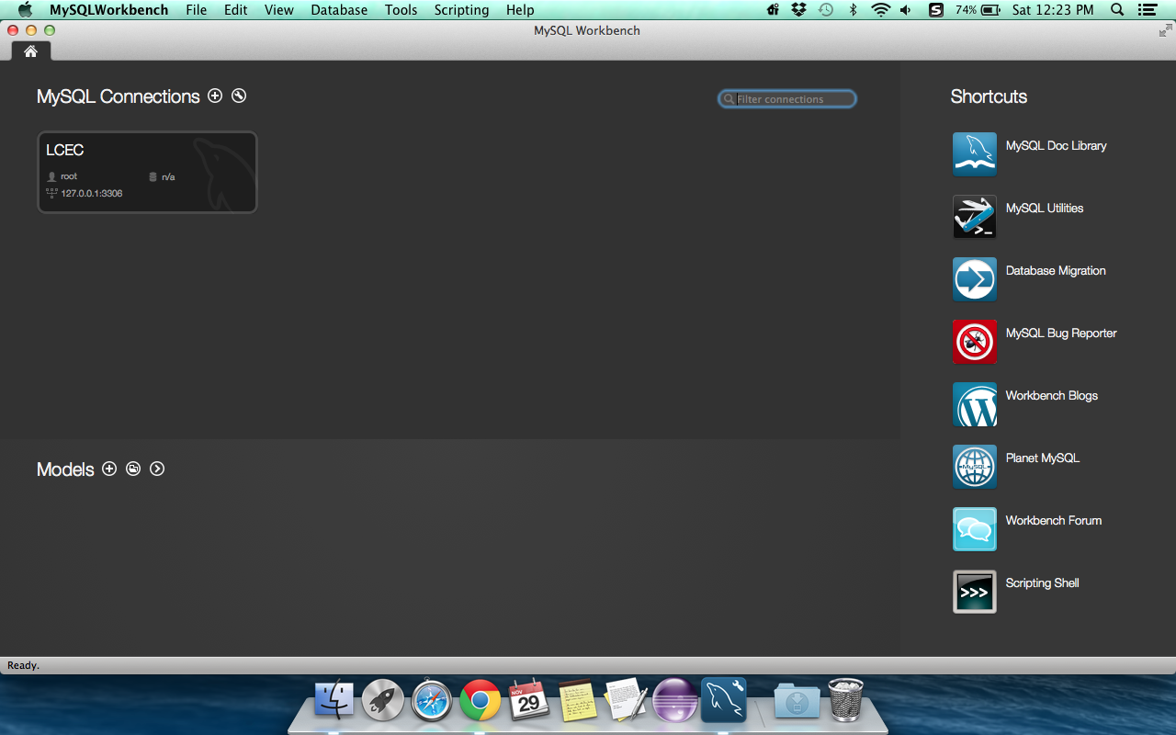

Use the scheme “test” and run all of the sql scripts in LCEC project in the following way:

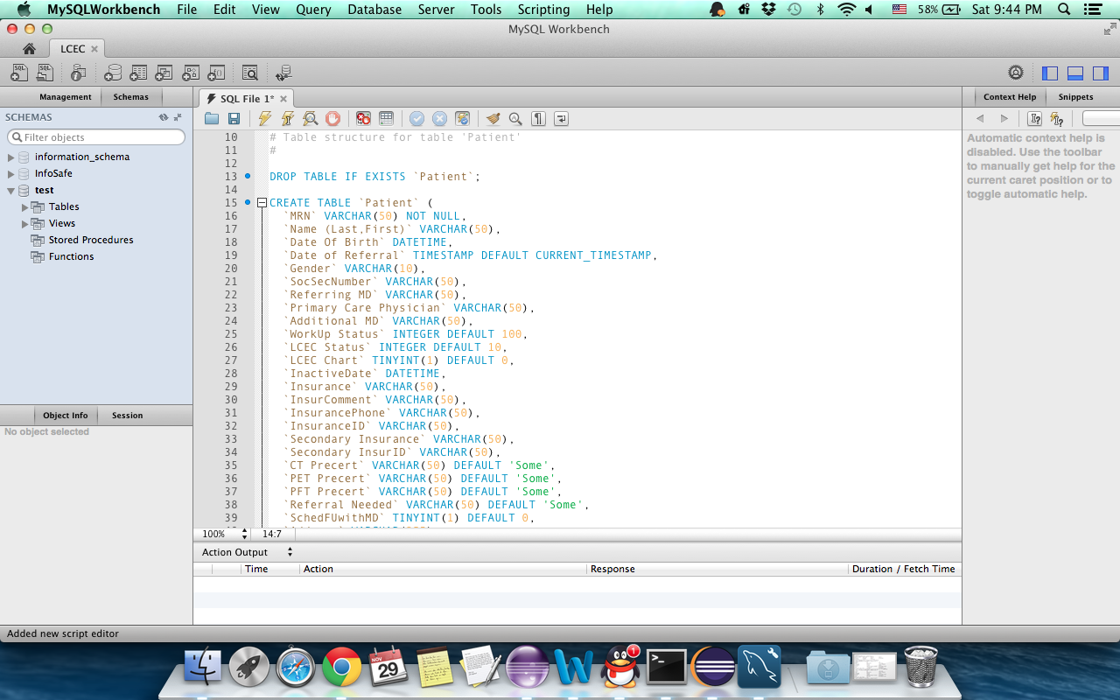

Until now, you have stored all the data into your database.

Step3:

Set up the environment:

Download JSF libraries:

Open Properties window. Right click the lcec-web project and select properties

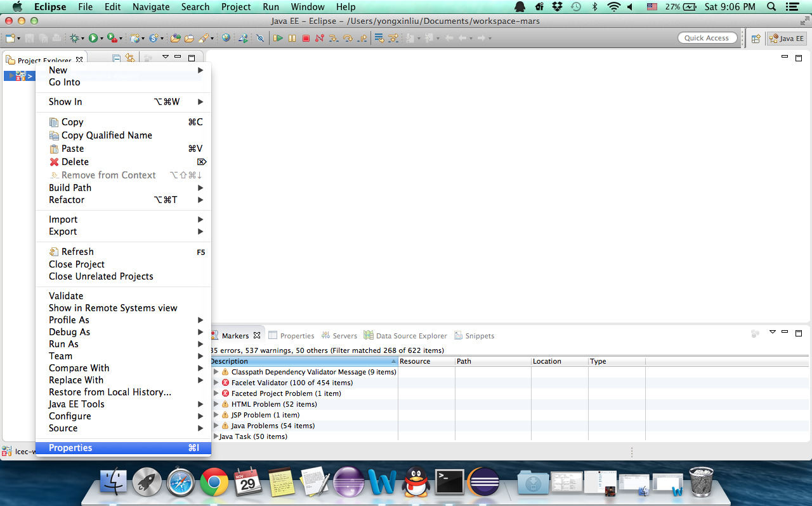

Select Project Facets/Java Server Faces

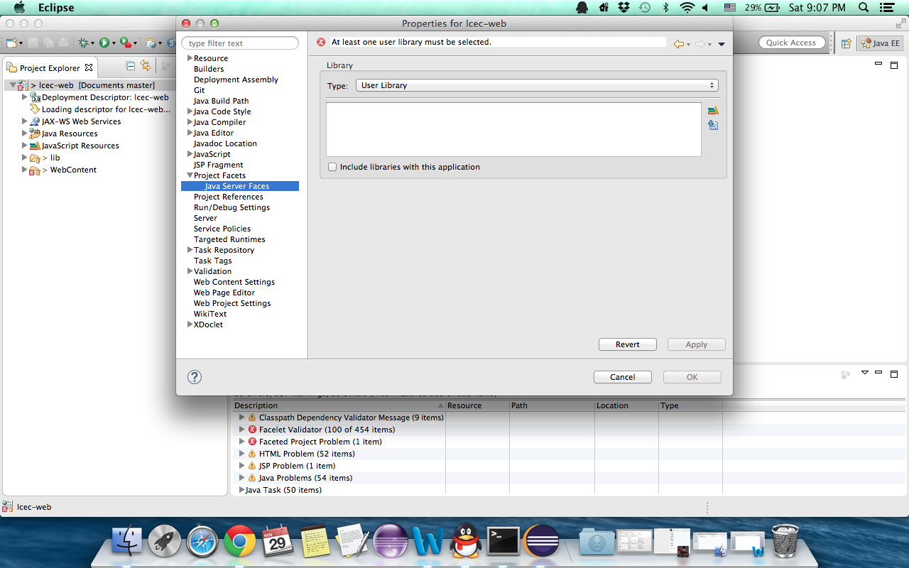

Click the download button 

Select JSF 2.0 (Apache Myfaces JSF Core-2.0 API 2.0.2), then next.

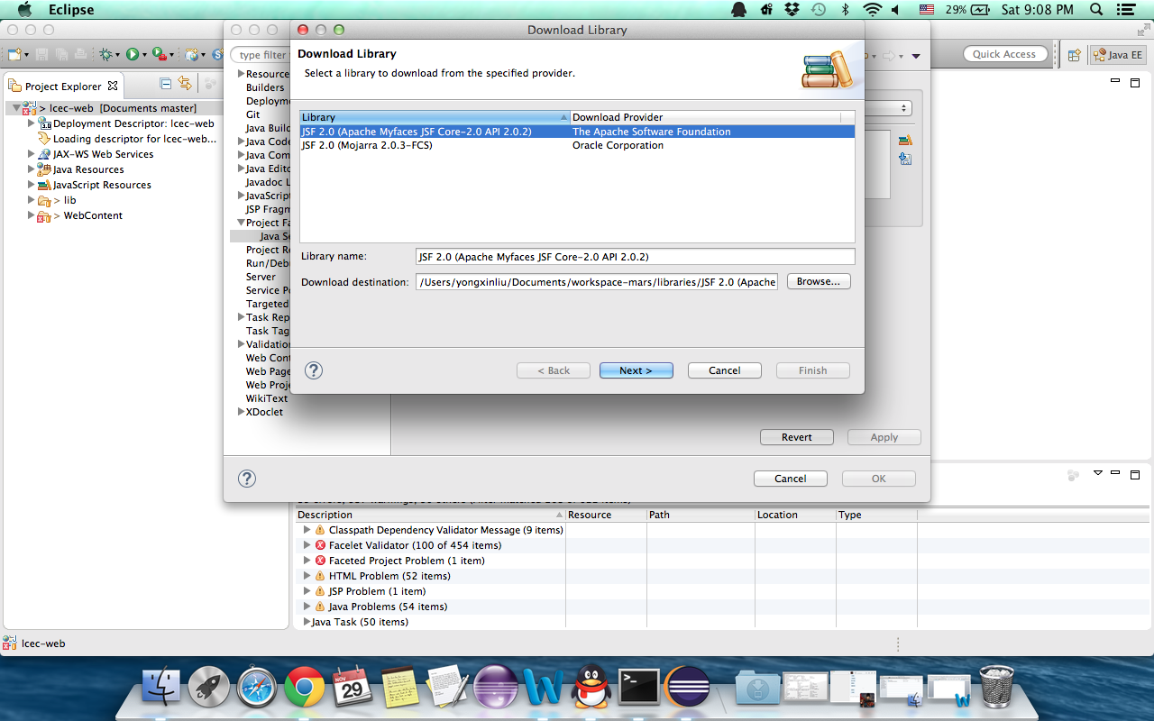

Check the box and accept the term of license, then Finish.

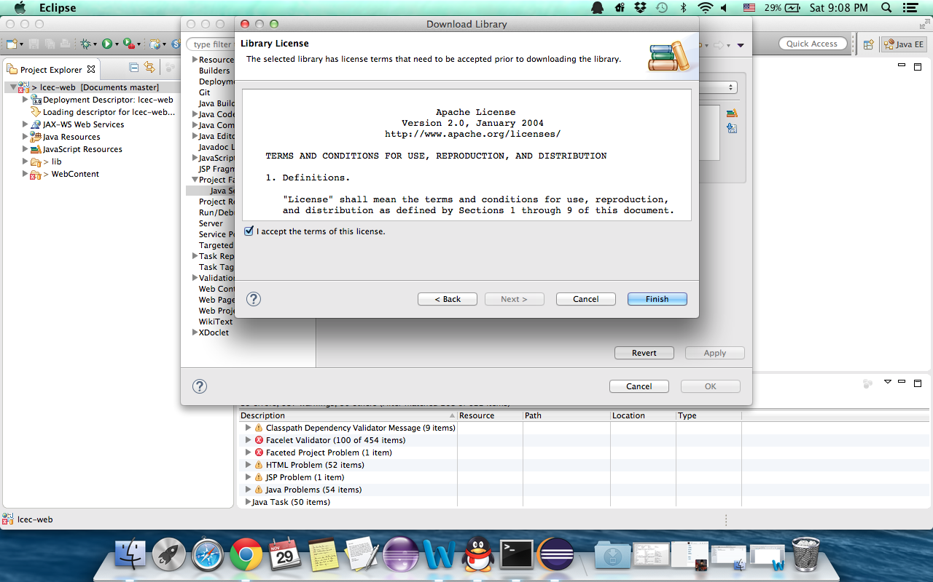

After that, you will see JSF library has downloaded on your machine.

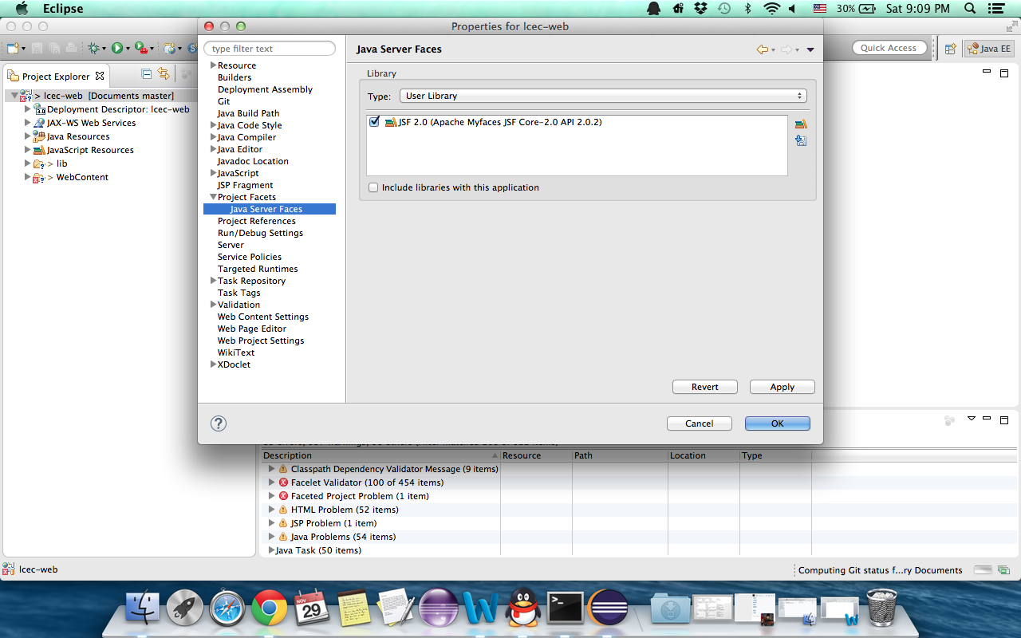

Include other libs into this project:

In the same Java Server Faces window, click on the button 

Click New,

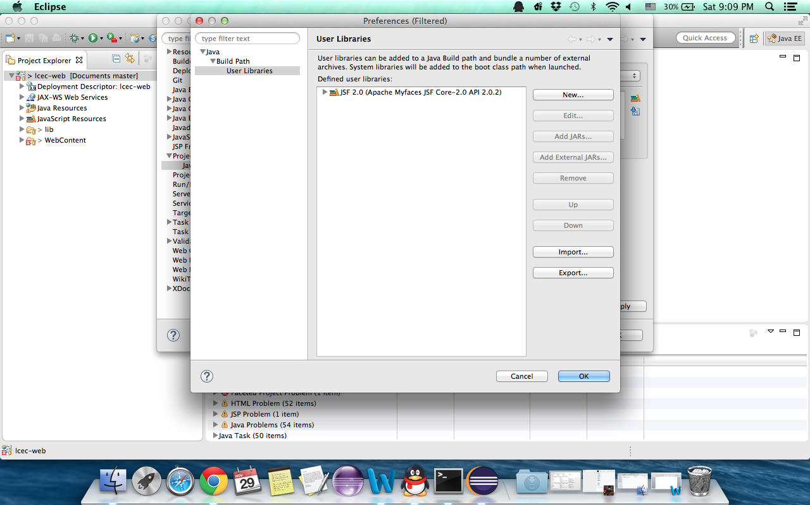  
Give a name, here we named it LCEC, then ok:

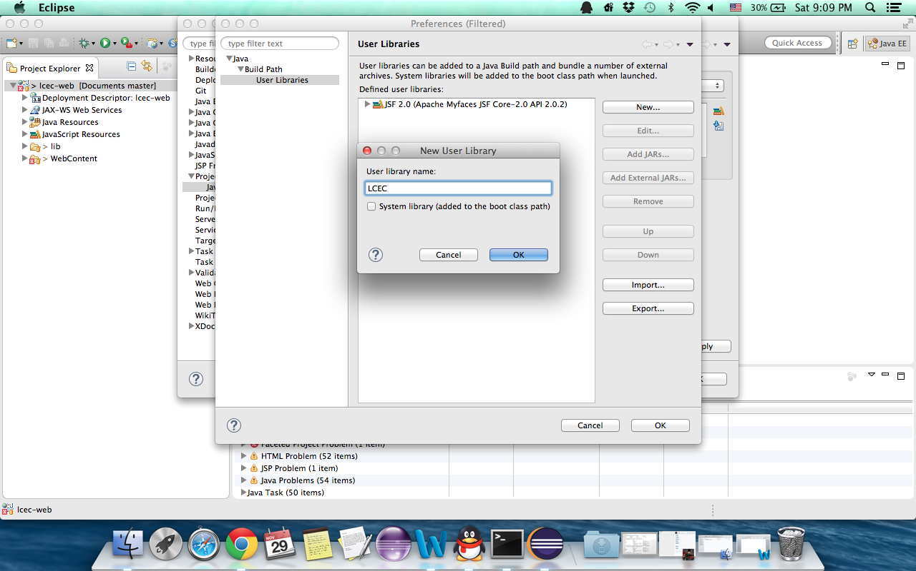

Click “Add External JARS”, import all the jars in the path $your workspace$/lcec-web/lib. Then Open.

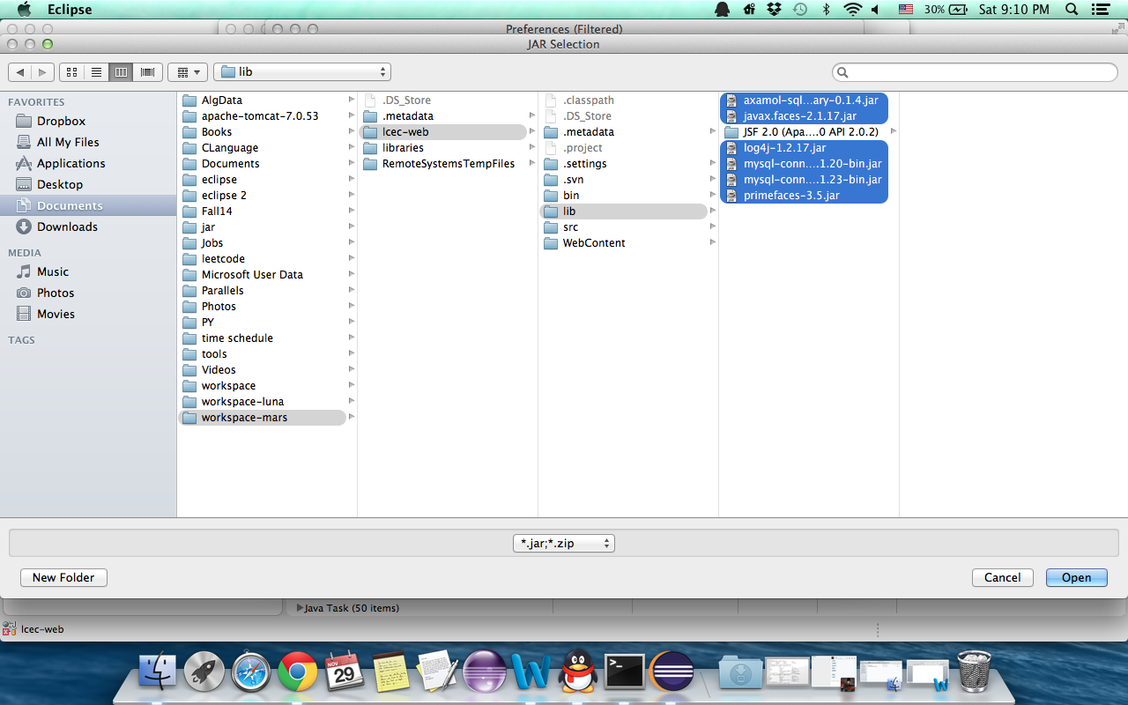

Then ok:

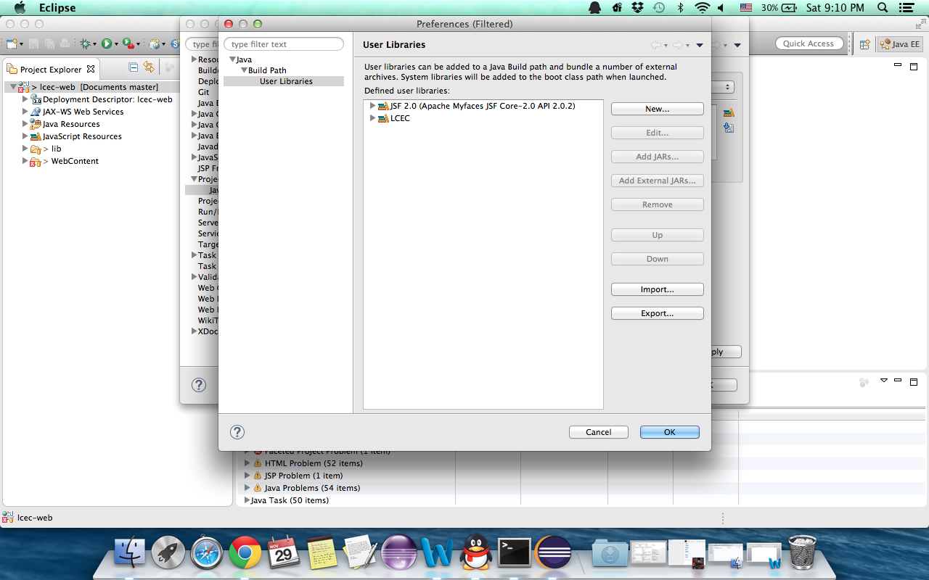

Check both JSF 2.0 and LCEC, then Apply

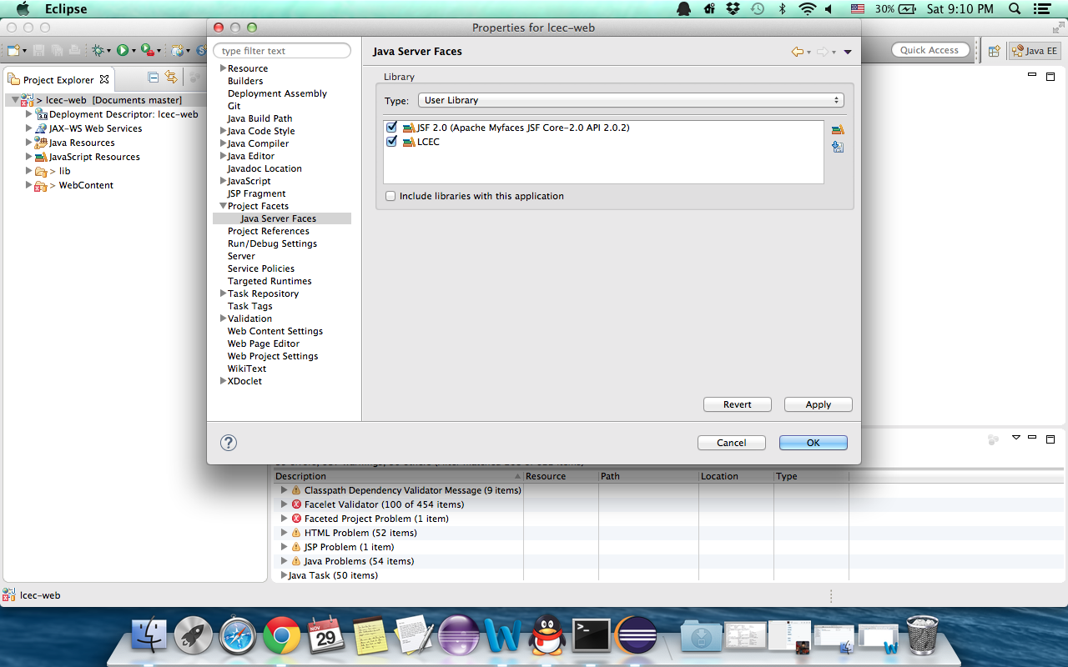

Step4:

Set up tomcat server:

First download tomcat server to your Mac:

Click Servers, then “No servers are available. Chick this link to create a new server…”

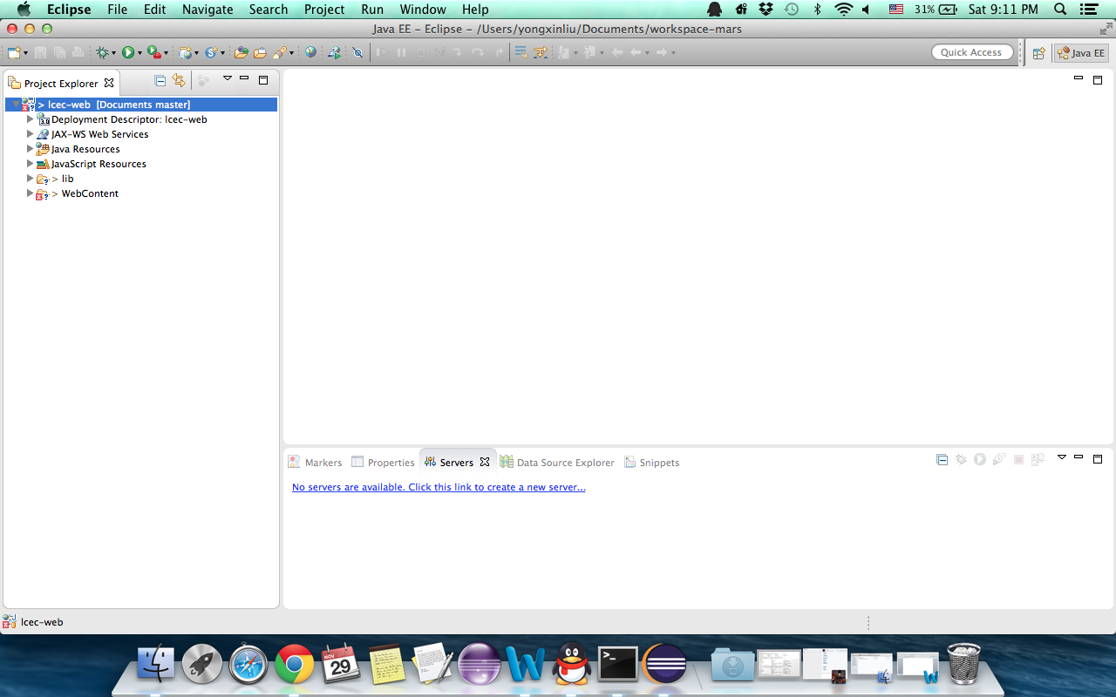

Select Apache/Tomcat v7.0 Server, then next.

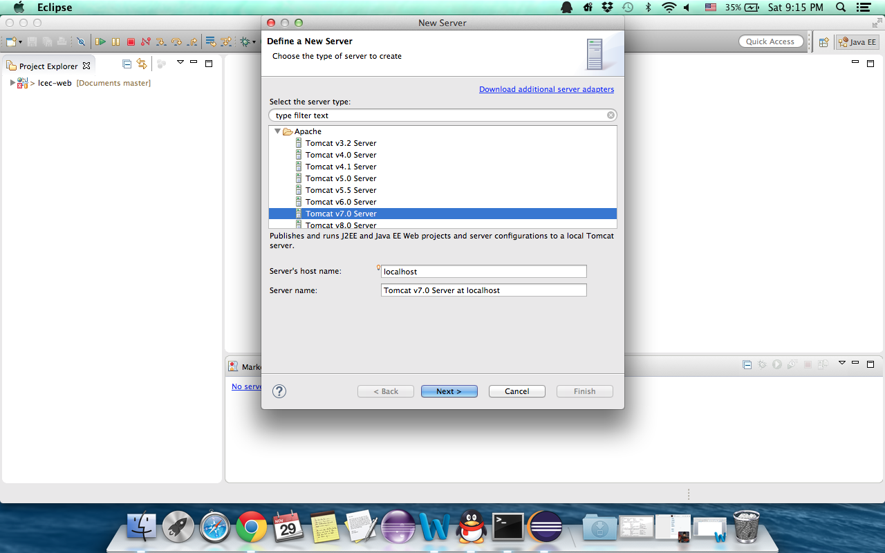

Select lcec-web, then click Add, then finish.

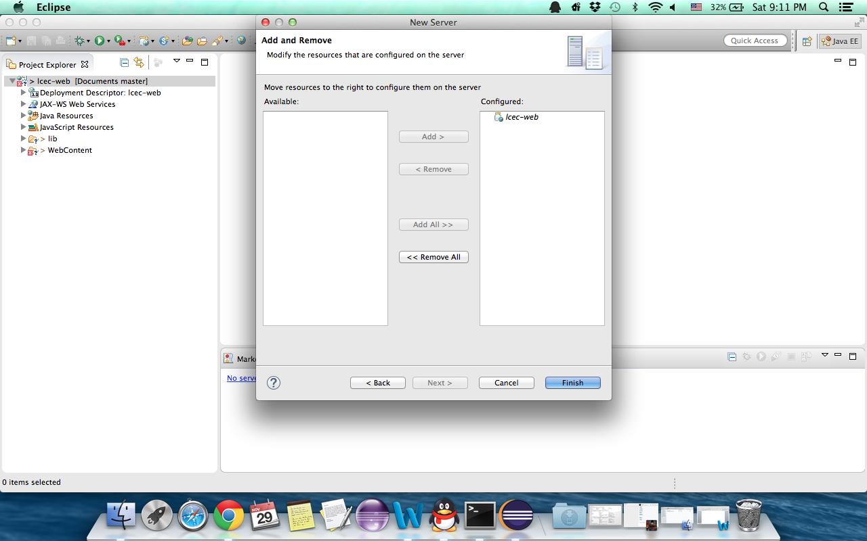

Step 5:

Open Properties window too, Check in the Targeted Runtimes and Server to see whether it is the right server.

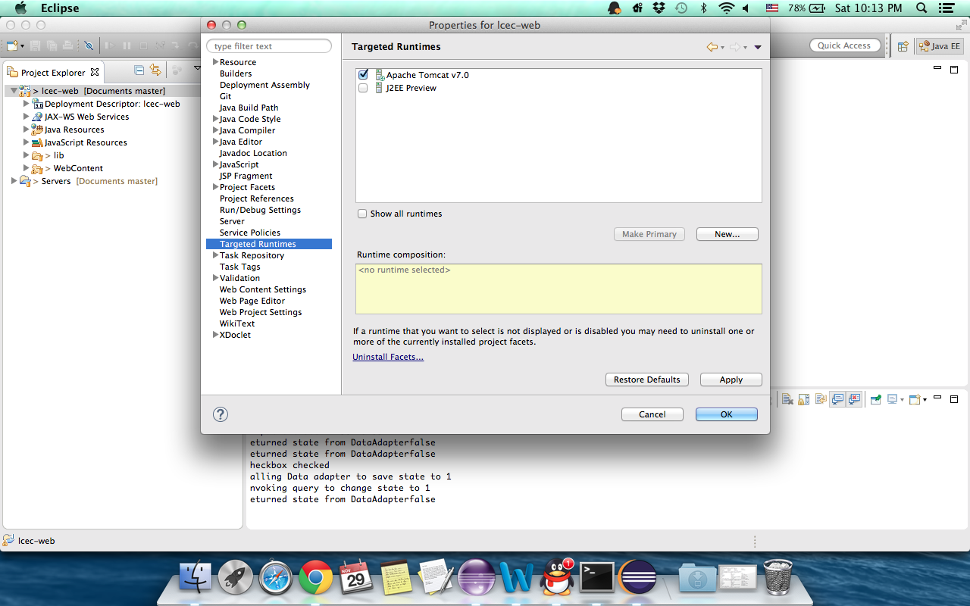

Select Project Facets, set as the following image:

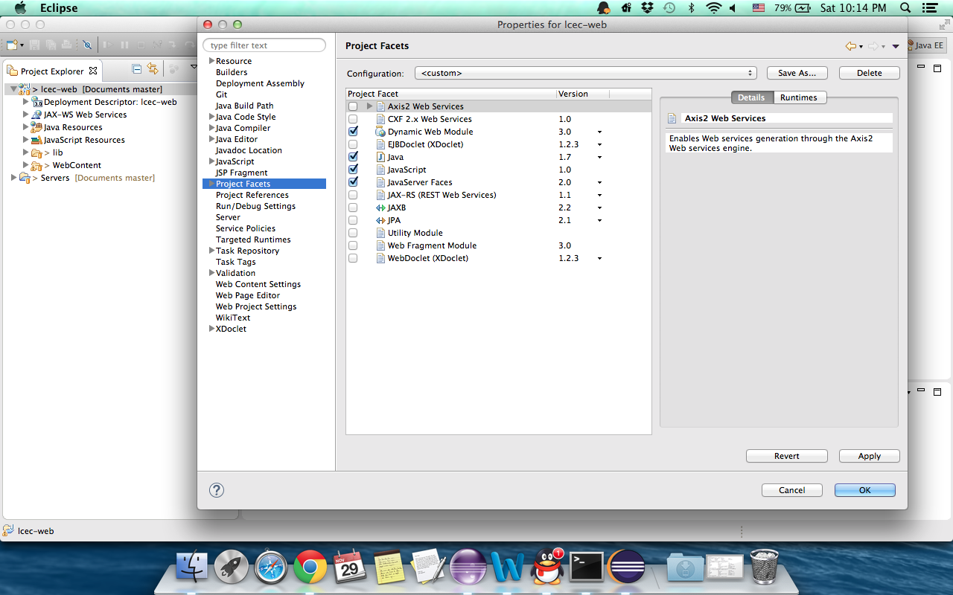

Step6

After those settings, copy all the jars in $your workspace$/lcec-web/lib(except the JSF part) to the apache-tomcat lib folder.

A reminder:

If your mysql password is not “pass4root”, change it at the Dao.properties file:

But please remember, don’t submit this change to the source.

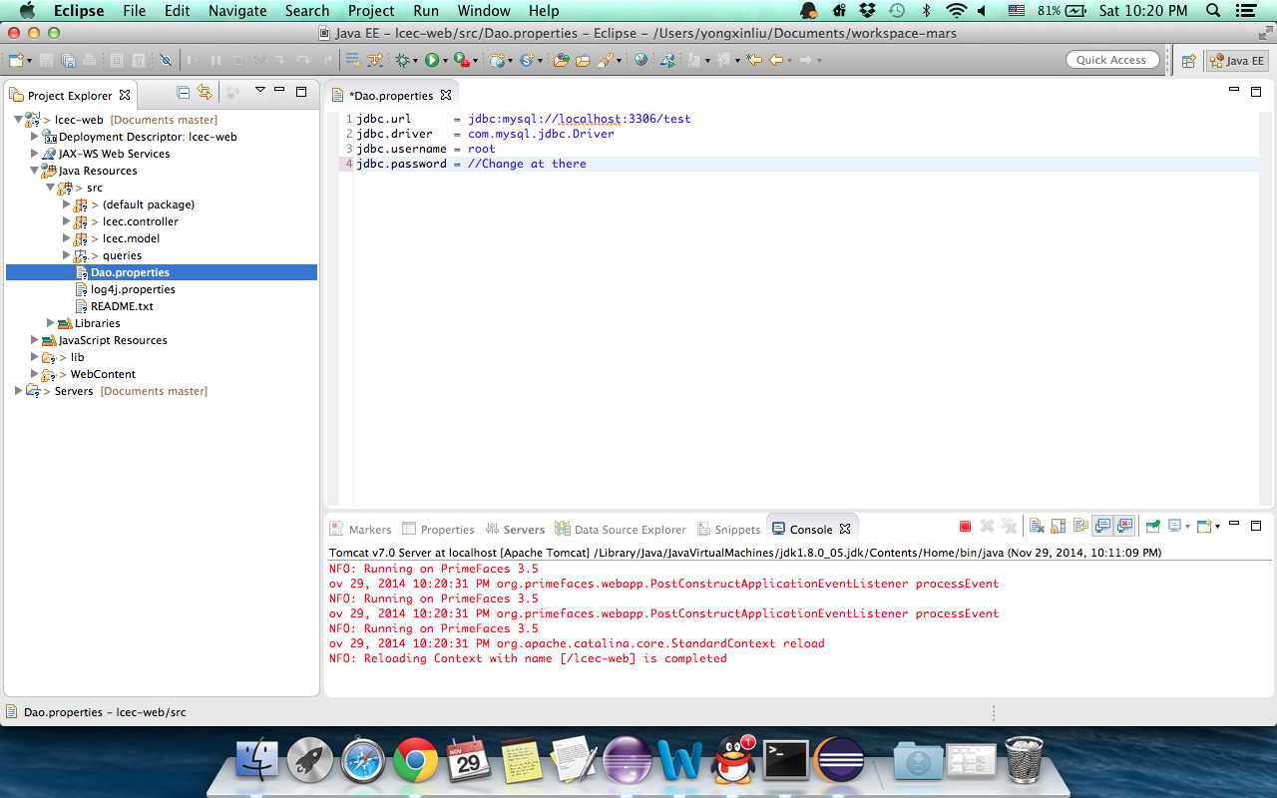

Until now, you have completed the environment settings, now run lcec-web project, you can see the index page:

